Velo Nicotine Pouches in Dubai: All You Need to Know About This Hot Trend

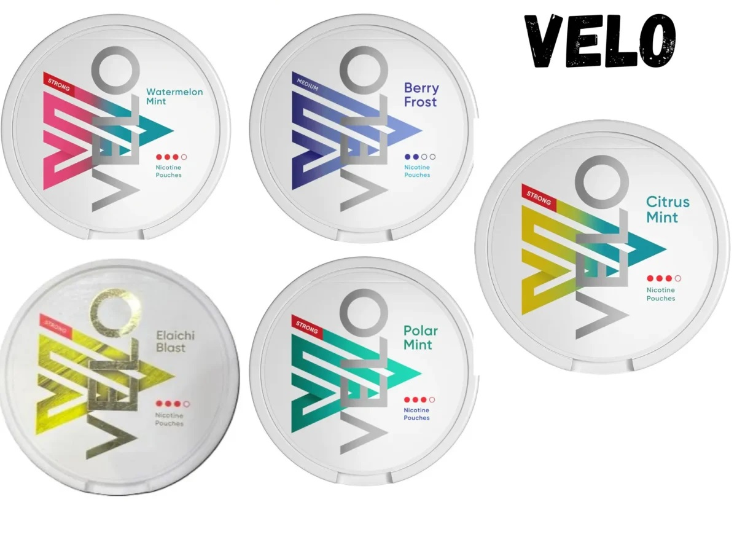

Dubai, known for its modern horizon, energetic culture, and lavish way of life, is seeing a change in the manner in which its occupants approach nicotine utilization. As wellbeing cognizant propensities become the dominant focal point, Velo nicotine pockets have arisen as a famous sans smoke elective, offering comfort, caution, and development. This pattern is rapidly reshaping the scene of nicotine use in the city, lining up with worldwide movements toward better way of life choices.

What Are Velo Nicotine Pockets?

Velo nicotine pockets are a state of the art answer for nicotine purchasers looking for an option in contrast to customary smoking or vaping. These [nicotine pouch dubai](https://pouchesuae.com/) pockets are little, white, and sans tobacco, containing a mix of nicotine, regular strands, and enhancing specialists. Intended to be put tactfully under the lip, they give a consistent arrival of nicotine, killing the requirement for smoke, debris, or fume.

The allure of Velo lies in its effortlessness. With no burning or scent, these pockets are an astounding decision for the individuals who need to keep away from the social disgrace of smoking while as yet partaking in the fulfillment of nicotine.

Why Are Velo Nicotine Pockets Acquiring Fame in Dubai?

Dubai's assorted populace and moderate position on wellbeing make it an ideal market for creative items like Velo nicotine pockets. Here's the reason they are turning into an easily recognized name:

1. Sans smoke and Watchful

Smoking boycotts in broad daylight spaces are totally upheld in Dubai, making sans smoke choices like Velo especially appealing. Whether in workplaces, eateries, or shopping centers, clients can partake in these pockets without drawing consideration or disregarding guidelines.

2. Better Way of life Patterns

As worldwide mindfulness around smoking-related wellbeing chances develops, Dubai inhabitants are progressively taking on options that lessen hurt. Velo pockets take special care of this interest by offering a sans tobacco choice that kills openness to hurtful poisons related with burning.

3. Accommodation and Movability

Velo nicotine pockets come in minimized, travel-accommodating tins, making them simple to convey and utilize anyplace. With no requirement for lighters, chargers, or extra frill, they offer a problem free encounter for occupied experts and in a hurry people.

4. Extensive variety of Flavors

The range of flavors accessible is one more explanation for the taking off notoriety of Velo in Dubai. From invigorating mint to fruity mixes like berry or citrus, these pockets take care of assorted taste inclinations, improving the general insight.

Step by step instructions to Utilize Velo Nicotine Pockets

Utilizing Velo nicotine pockets is clear:

Select Your Pocket: Pick your ideal flavor and nicotine strength from the tin.

Place Under the Lip: Supplement the pocket between your gum and upper lip. It will sit carefully without causing inconvenience.

Partake in the Delivery: Nicotine is step by step delivered north of 20-30 minutes, giving a supported encounter.

Discard Dependably: Once finished, basically dispose of the pocket in a garbage can.

This consistent cycle pursues Velo a useful decision for those looking for straightforwardness and productivity.

Flavors and Qualities: Tweaking the Velo Experience

Velo nicotine pockets are accessible in different flavors and qualities, permitting clients to customize their experience. Well known flavors include:

Mint: A fresh and empowering decision for the individuals who favor a reviving burst.

Berry: Sweet and tart, ideal for a fruity contort.

Citrus: Brilliant and lively, ideal for a jolt of energy.

Tropical: Outlandish and energetic, suggestive of excursion flows.

Nicotine qualities commonly range from gentle (4mg) to solid (10mg or higher), taking special care of both light and experienced clients.

The Administrative Scene in Dubai

Dubai has rigid regulations administering tobacco and nicotine items, mirroring its obligation to general wellbeing and security. While customary smoking is intensely confined, without smoke options like Velo are acquiring acknowledgment, gave they go along guidelines.

Customers are encouraged to buy Velo nicotine pockets just from authorized retailers or approved web-based stages to guarantee realness and adherence to lawful norms.

Advantages of Changing to Velo Nicotine Pockets

Doing the change to Velo nicotine pockets offers various benefits:

1. Better Other option

Without tobacco or ignition, these pockets fundamentally decrease openness to hurtful synthetic compounds, lining up with hurt decrease techniques.

2. Scentless and Sans stain

Not at all like cigarettes, Velo pockets leave no waiting smell or stains, making them a cleaner choice for individual and group environments.

3. Harmless to the ecosystem

With no cigarette butts or fume emanations, Velo pockets add to a cleaner climate, lining up with Dubai's supportability objectives.

4. Savvy

Over the long haul, utilizing Velo can be more affordable than smoking or vaping, as the pockets are intended for delayed use.

Where to Purchase Velo Nicotine Pockets in Dubai

As the interest for Velo nicotine pockets develops, they are opening up in Dubai. Purchasers can track down them at:

Nearby Retailers: Chose corner shops and drug stores stock Velo items, guaranteeing openness.

Online Stages: Authorized web based business sites offer the accommodation of home conveyance, with choices for mass buys.

Specialty Stores: Tobacco and nicotine niche stores frequently convey a broad scope of Velo flavors and qualities.

While buying on the web, consistently check the stage's credibility to stay away from fake items.

Tips for First-Time Clients

In the event that you're new to Velo nicotine pockets, here are a few hints to upgrade your experience:

Begin with Gentle Strength: Start with lower nicotine levels to measure your resistance.

Try different things with Flavors: Attempt various flavors to find your #1.

Use Reasonably: Adhere to the prescribed utilization to forestall overconsumption.

Remain Hydrated: Drinking water can assist with alleviating any dryness brought about by the pockets.

The Fate of Nicotine Utilization in Dubai

As Dubai keeps on embracing development and health, the notoriety of without smoke items like Velo nicotine pockets is supposed to take off. These pockets take special care of individual inclinations as well as line up with more extensive cultural objectives of diminishing smoking predominance and advancing better other options.

With their accommodation, tact, and wellbeing cognizant allure, Velo nicotine pockets address the fate of nicotine utilization in Dubai. Whether you're a long-lasting smoker hoping to stop or somebody looking for a cutting edge other option, Velo offers a flexible and fulfilling arrangement.